TO DO :
1. report writing
Contents =
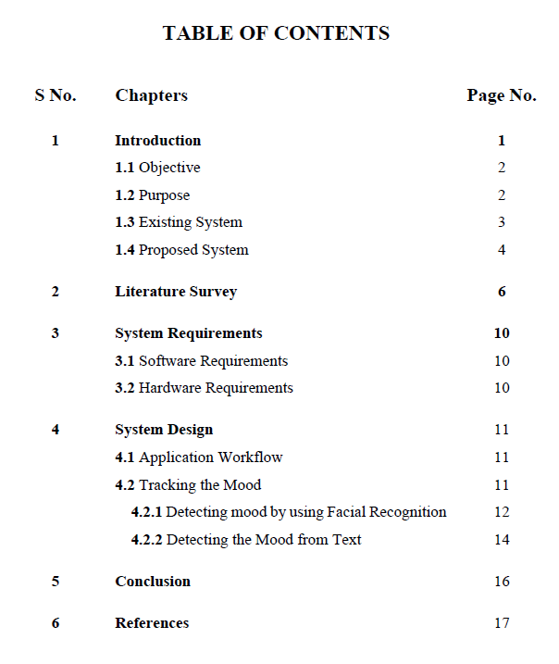

2. collect relevant research papers =
https://www.ijert.org/research/an-online-system-for-household-services-IJERTCONV6IS13012.pdf
{papers on chatbots and blockchain – not required}

3. ppt for final review
4. diagrams =
* high level design - like application workflow = represent everything which happens in a system under 1 single diagram.
* lower level design = elaborate more on every process / action by designing separate diagrams .
* db schema design
* wireframes / interface designs
application workflow example=

Low level design example =
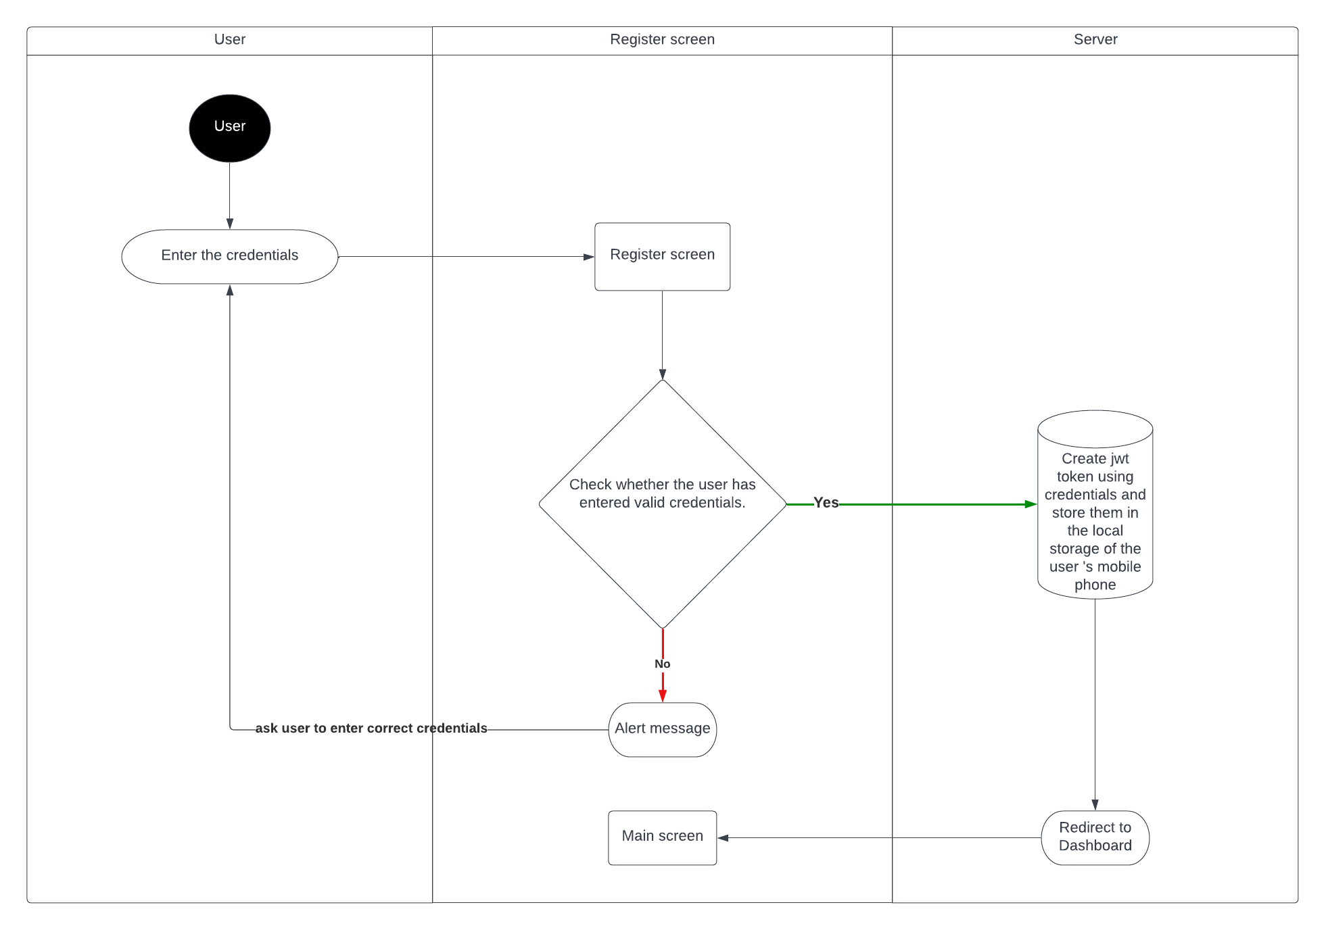
Db schema diagram example =
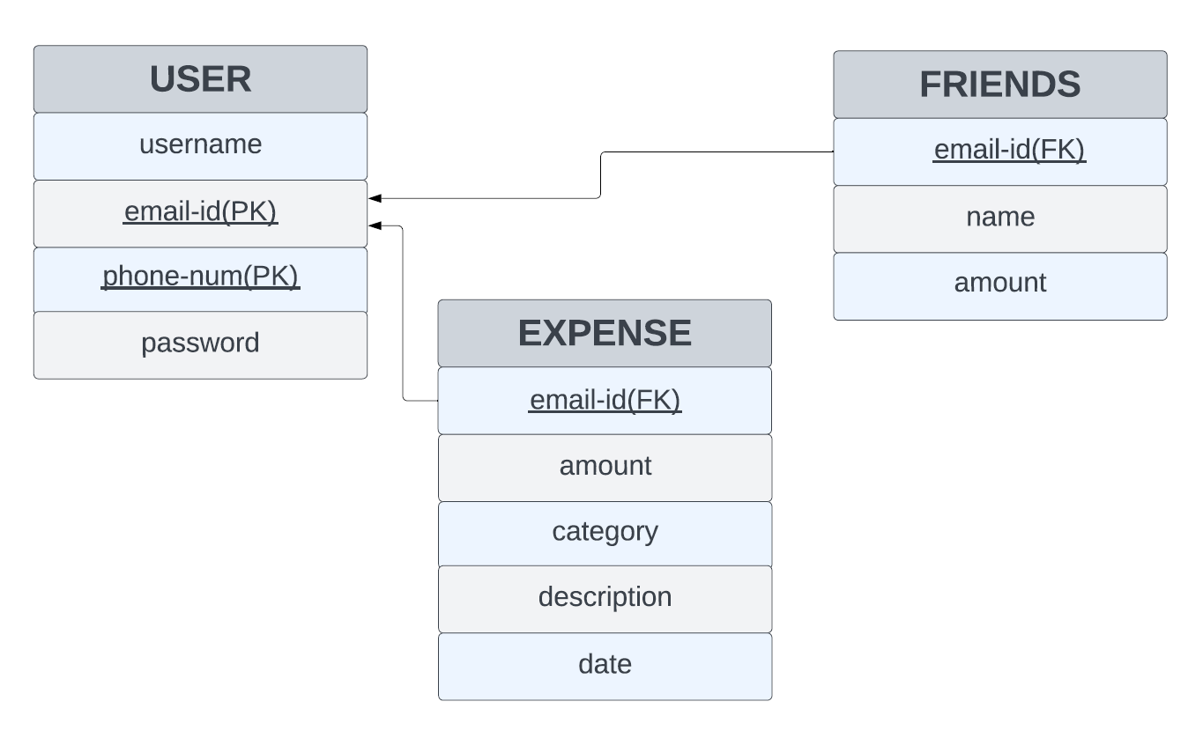

Wireframe example =
